Unit 9 Day 1
Warm-Up:
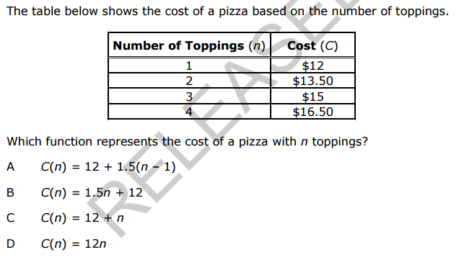
1.

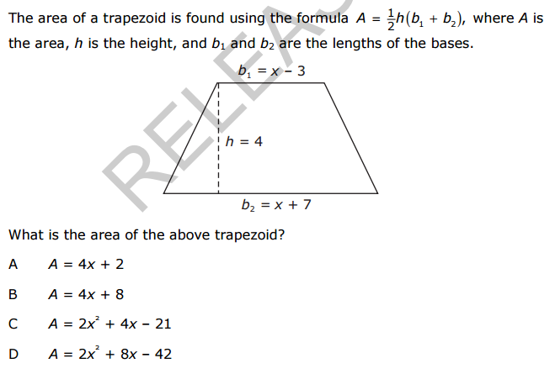
2.

Use the websites listed below to find information about the vocabulary words for this unit. You will complete a Vocabulary Table which includes the word, definition and an example/picture.

http://www.amathsdictionaryforkids.com/dictionary.html
Box and Whisker Plot
Dot Plot
Frequency Table
Histogram
Maximum
Mean
Median
Minimum
Mode
Outlier
Range

http://www.mathsisfun.com/data
First Quartile
Interquartile Range
No Skew (Symmetric)
Negative Skew (Skewed left),
Positive Skew (Skewed right))
Standard Deviation
Third Quartile

