Unit 9 Day 3
Warm-Up:
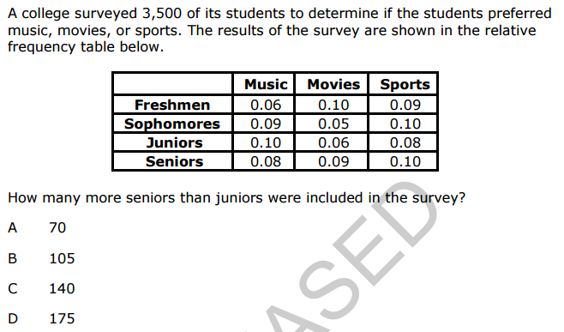
1.

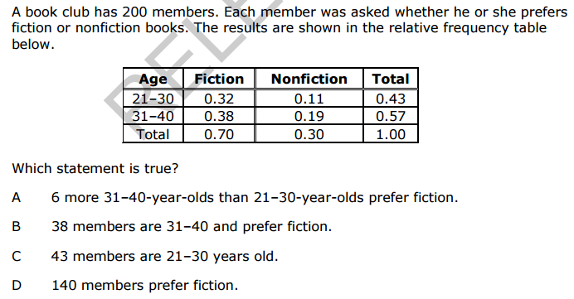
2.

Math 1 Unit 9 Learn Zillion Lesson Videos Name ____________________________
Video Watch List:

Create a box plot

Compare box plots using center and spread
Take notes as you watch each video. You may watch in any order but you must have 5 different sections of notes, one for each video.

