AFM Unit 2 Statistics
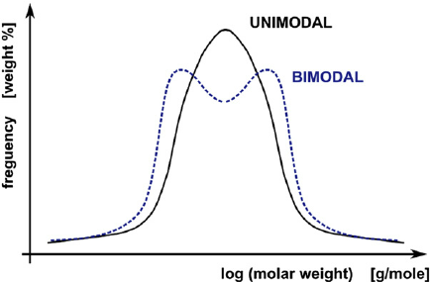
Unimodal vs. Bimodal Distribution

Negatively vs. Positively Skewed Bell Curve
